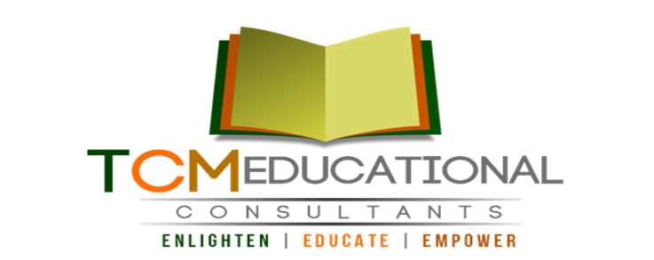
Sponsorship Package

Work With Us

Dear Business Owner/Representative,

On behalf of T.C.M. Educational Consultants Corporation I would like to invite you to take part in an incredible opportunity to support our nonprofit organization Mentoring and Tutoring afterschool program, “G.A.A.P.”

You will have the chance to promote your business, while helping those who are less fortunate. T.C.M. Educational Consultants Corporation is constructively involved in helping students in the Lexington and regional communities achieve their higher education goals. The event proceeds will benefit outstanding students in grades 9-12 and college who have shown outstanding leadership, community involvement and scholastic excellence

In return for your generosity, we will be promoting your business through brand-recognition via advertisement in our company brochure, website, and our upcoming T.C.M. Affiliate Network events and scholarship benefit banquet to honor T.C.M. Educational Consultants students, sponsors, donors and VIP guests.

Our promotional efforts will provide you with a great opportunity to increase recognition of your company in the city of Lexington and the surrounding area.

I sincerely hope you will take this proposal into consideration as our event depends greatly on the generous support of members of the local business community such as yourself. If you have any questions, comments, or concerns, please do not hesitate to contact me at t.c.m.ed.consultants@live.com.

Thank you for your consideration and interest in supporting our students and our organization for this event. I look forward to speaking with you soon.

Sincerely,

Thea M. Mason
Founder & President
T.C.M. Educational Consultants Corporation
www.tcmhighereducation.com

About Us

In March 2011, T.C.M. Educational Consultants Corporation, a nonprofit organization, was created in Detroit, Michigan by our founder and president Thea M. Mason. The dream of our founder was to establish an organization that would provide information, resources and connections to disadvantaged persons seeking higher education. The reasoning and benefit for establishing an office in Kentucky was to generate awareness among students in this area about securing their higher education. T.C.M. Educational Consultants Corporation opened its Kentucky office in October of 2012, with 1 client and big dreams. Presently we have clients from New York to Texas.

About the Program

The purpose of the “G.A.A.P” academic program is to present an opportunity for students from low and disadvantaged backgrounds to narrow the learning “gap” that exists in students from disadvantaged backgrounds and to provide academic support through tutoring and mentoring programs. This “G.A.A.P” after school program will build a bridge to narrow the learning “gap”, provide students with a chance to experience education from a different perspective and help build self-confidence. Students will participate in various events and seminars. This program will give insight to students who struggle daily in the classroom and it will teach students about opportunities that exist for them educationally.

Sponsorship Benefits

Sponsors have the choice to select the various levels of exposure and benefits from sponsorship of our event. These benefits are outlined in the four packages listed below:

Title Sponsor: $5,000
- Listed as partnering Sponsor in brochure
- Name on Promotional material
- Named as TCM Title Sponsor on Website
- Reserved seating for 8 for all upcoming TCM Affiliate Network events
- Company logo, website link on TCM Website
- Company name in event programs
- Company acknowledgement by our Founder and President during event

Diamond Sponsor: $2,500
- Company name on Gift bags
- Named as TCM Diamond Sponsor on Website
- Reserved seating for 6 for all upcoming TCM Affiliate Network event
- Company logo, website link on TCM Website
- Company name in event programs
- Company acknowledgement during events
- Company advertisement materials inserted in gift bags

Gold Sponsor: $1,000
- Named as TCM Gold Sponsor on Website
- Company logo, website link on TCM Website
- Company name in event programs
- Company advertisement materials inserted in gift bags

Silver Sponsor: $250-500
- Named as TCM Silver Sponsor on Website
- Company logo on TCM Website
- Company name in event programs
- Company advertisement materials inserted in gift bags

MONETARY SPONSORSHIP CONTRACT

Contact Name Organization

Address Line 1 Phone Number

Address Line 2 Email Address

Sponsorship Package: Details of Agreement
$5,000 - Title Sponsor $2,500 – Diamond Sponsor

$1,000 - Gold Sponsor
$250-500 - Silver Sponsor _________________________________________
Sponsor Amount: $______________

Upon signing this document, (name of sponsor) of (organization) has acknowledged that he/she has read, understood and agreed to the terms and conditions of this contract. The sponsor has agreed to pay the amount of $ and to provide the company logo for promotional purposes to T.C.M. Educational Consultants Corporation, in support of the “G.A.A.P” Program: Gaining Academic Aptitude through Perseverance.

SPONSOR T.C.M. Educational Consultants Corporation Representative

Printed Name/ Title Printed Name/ Title

Signature Signature

Date Date

Any additional terms in correspondence to this contract can be stated below and must be initialed by both the sponsor and the T.C.M. Educational Consultants Corporation representative prior to signing.

